Network Communication Technologies

Multi-User Real-Time Text Editor

Sumeyra Karsavran

June 2025

**1. INTRODUCTION**

**Objective:**  
 In this project, a system was developed that allows multiple users to work on text files simultaneously. The system consists of a WebSocket server and tkinter GUI-based clients.

**Technologies:**

* Python
* websockets (WebSocket protocol)
* tkinter (GUI)
* Asyncio (Asynchronous Programming)
* JSON (data exchange)

**2. SYSTEM ARCHITECTURE**

**2.1 General Structure:**

+------------------+ WebSocket +------------------+

| Client 1 | <--------------------> | Server |

+------------------+ +------------------+

↑ ↑

+------------------+ +------------------+

| Client 2 | <--------------------> | File System |

+------------------+ +------------------+

**2.2 Components:**

| **Component** | **Explanation** |
| --- | --- |
| **Server** | It manages all files. Saves and publishes changes. |
| **Client** | It offers an interface to the user. It provides operations such as file creation and editing. |
| **File System** | Files are stored in the server_files/ directory. The server writes the file to disk with each update. |

**3. SERVER APPLICATION**

**Key Duties:**

* Listens for WebSocket connections
* Creates, deletes and lists files
* Publishes changes made to a file to all users
* Save/upload files to the server directory

**Data Structures:**

| **Variable** | **Explanation** |
| --- | --- |
| clients | Maintains WebSocket connections and each client's open file/username |
| files | File names and contents are stored as a dictionary |

**Operation Diagram (Server):**

Client sends message ── ▶ JSON is resolved ── ▶

│ │

├─ ▶ "set_username" ├─ ▶ Username is stored

├─ ▶ "list_files" ├─ ▶ File list is sent

├─ ▶ "create_file" ├─ ▶ File is created, written to disk

├─ ▶ "delete_file" ├─ ▶ File deleted, published

└─ ▶ "insert"/"delete" └─ ▶ Text is updated, written to disk, and propagated

**4. CLIENT APP**

**Key Duties:**

* Retrieves the username from the user
* Shows the list of files
* Shows the contents of the selected file
* Notifies the server of keyboard changes made
* Takes the changes made by other users and reflects them in the application

**Interface Features:**

| **Component** | **Function** |
| --- | --- |
| Listbox | Shows the list of files on the server |
| Text | Shows the contents of the active file and allows editing |
| Button | Used for file creation and deletion |

**Functioning Diagram (Client):**

User interaction ── ▶ Event Handler (GUI)

│

├─ ▶ File selection ── ▶ open_file request

├─ ▶ Keyboard key ── ▶ insert/delete request

├─ ▶ Buttons ── ▶ create/delete_file request

▼

Incoming messages are asynced and transferred to the GUI thread

**5. MESSAGE STRUCTURES (JSON)**

| **Action** | **Sender** | **Area** | **Explanation** |
| --- | --- | --- | --- |
| set_username | Client | Server | Reports username |
| list_files | Client | Server | Requests the file list |
| files_list | Server | Client | Sends existing files |
| create_file | Client | Server | Creates a new file |
| delete_file | Client | Server | File deletion request |
| open_file | Client | Server | Requests file contents |
| file_content | Server | Client | Sends file contents |
| insert | Client | Server & Other Clients | Instructs the addition of characters to the content |
| Delete | Client | Server & Other Clients | Deletes specific characters |

**6. OPERATING PRINCIPLES**

**6.1 States**

| **State** | **Explanation** |
| --- | --- |
| Disconnected | WebSocket connection not yet established |
| Connected | WebSocket connection established, username not sent |
| LoggedIn | Username submitted, server file list may return |
| FileSelected | A file is selected, its contents are retrieved |
| Editing | User editing text, submitting changes |

**6.2 Transitions**

| **Event** | **Source Status** | **Target Situation** | **Explanation** |
| --- | --- | --- | --- |
| connect() | Disconnected | Connected | WebSocket connection established |
| send_username() | Connected | LoggedIn | Username submitted |
| list_files() | LoggedIn | LoggedIn | File list retrieved from server |
| select_file() | LoggedIn | FileSelected | File selected, content retrieved |
| edit_text() | FileSelected | Editing | User added/deleted text |
| receive_edit() | FileSelected/Editing | Editing | Changes made by other users were taken |
| disconnect() | *Any State* | Disconnected | Connection broken/closed |

**6.3 FSM Diagram**

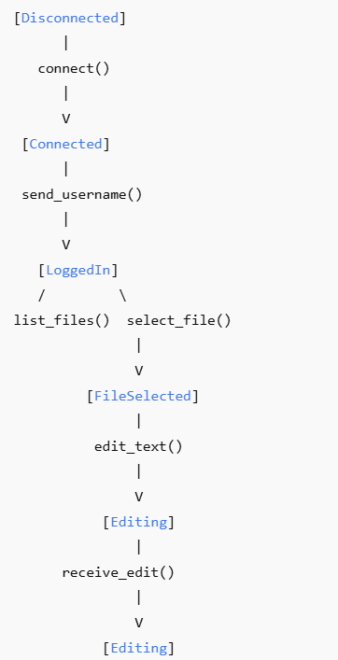

**6.4 FSM Mermaid Notation**

stateDiagram-v2

[*] --> Disconnected

Disconnected --> Connected: connect()

Connected --> LoggedIn: send_username()

LoggedIn --> LoggedIn: list_files()

LoggedIn --> FileSelected: select_file()

FileSelected --> Editing: edit_text()

Editing --> Editing: receive_edit()

FileSelected --> Editing: receive_edit()

Disconnected <--> [*]: disconnect()

**6.5 Protocol Message Types and Transaction Table**

| **Message Type (action)** | **Sender** | **Buyer** | **Message Content** | **Buyer's Action** |
| --- | --- | --- | --- | --- |
| set_username | Client | Server | { "action": "set_username", "username": "John" } | Defines the user to the clients dictionary. |
| list_files | Client | Server | { "action": "list_files" } | files_list returns the list of files with the message. |
| files_list | Server | Client | { "action": "files_list", "files": ["a.txt", "b.txt"] } | Updates the list box on the interface. |
| create_file | Client | Server | { "action": "create_file", "filename": "yeni.txt" } | files list, writes to disk, files_list paths to all clients. |
| delete_file | Client | Server | { "action": "delete_file", "filename": "sil.txt" } | files list, removes the file on the disk, publishes files_list message. |
| open_file | Client | Server | { "action": "open_file", "filename": "a.txt" } | It finds the file contents, sends file_content message to the client. |
| file_content | Server | Client | { "action": "file_content", "filename": "a.txt", "content": "..." } | Populates the Text field with incoming content. |
| insert | Client | Server | { "action": "insert", "filename": "a.txt", "index": "2.5", "content": "a" } | Adds content to the specified location, saves the file, sends the message to other clients. |
| Delete | Client | Server | { "action": "delete", "filename": "a.txt", "index": "2.5", "length": 1 } | Deletes the character(s) in the specified location, saves them, sends them to other clients. |
| insert | Server | Client | { "action": "insert", "filename": "a.txt", "index": "2.5", "content": "a" } | If the open file matches, it adds to the client's interface. |
| Delete | Server | Client | { "action": "delete", "filename": "a.txt", "index": "2.5", "length": 1 } | If the open file matches, the client deletes the corresponding character(s). |
| ConnectionClosed | - | - | - | Server: removes from the list of clients.  Client: The GUI continues to work, but the connection is lost. |

**6.6 Basic Principle of Compatible Communication of Two End Systems Without Knowing Coding**

1. The parties do not know how each other works.
   * For example, the client doesn't know how the server stores files.
   * The server also does not know how the client's GUI is drawn.
2. They both only implement the protocol.
   * The client sends a "create_file" message.
   * The server only checks that the message is "action": "create_file" and takes the necessary action.
3. Mutual understanding guarantee:
   * Thanks to the use of JSON, every domain ("filename", "content") is open and fixed.
   * Both parties act according to these areas and do not comment on what the data in the content is.

**6.7 Protocol Flow: Diagram Symbol Representation**

+-----------------+ +----------------+

| Client | | Server |

+-----------------+ +----------------+

| |

|--- set_username ---------->| Start a session

|--- list_files -------------->| Request file list

| |

|<-- files_list --------------| Get the list

|--- create_file ------------>| Create a file

| |

|<-- files_list -------------- | Current list

|--- open_file -------------->| Request file content

|<-- file_content ------------| Get content

| |

|--- insert / delete -------->| Make arrangements

|<-- insert / delete ---------| Spread to other clients

| |

|--- delete_file ------------>| Delete file

|<-- files_list --------------| Current list

**7. SECURITY AND RESTRICTIONS**

* Users can't see each other's IDs (only content syncs)
* There may be some race cases in simultaneous writing (line-based analysis can be applied)

**8. DEVELOPMENT SUGGESTIONS**

* **Username Representation:** Username can be displayed in every edit.
* **Versioning:** File versions can be stored.
* **Access Authorizations:** Special file permissions can be added to each user.

**9. CONCLUSION**

This project is very fruitful in terms of experiencing the process of developing a real-time collaboration application with WebSocket and demonstrating how technologies such as asyncio and tkinter can work together. It is a structure that can form the basis for scenarios such as different users working on a document simultaneously.

**10. SCREENSHOTS & PRINTOUTS**

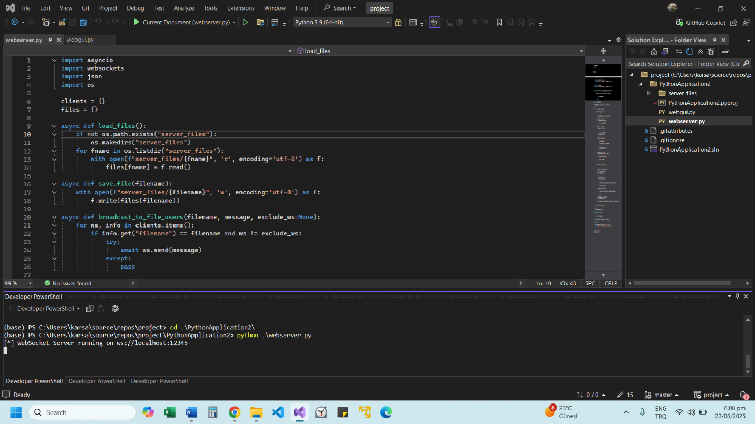

Connecting to the server

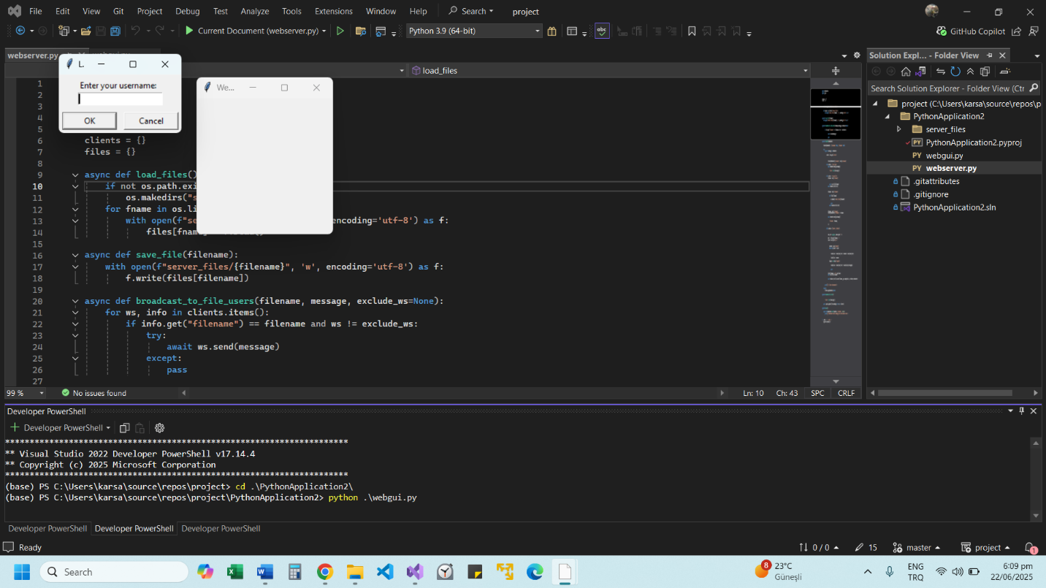

The screens that appear after executing the client code are shown. When you type a username, the text editor screen is active.

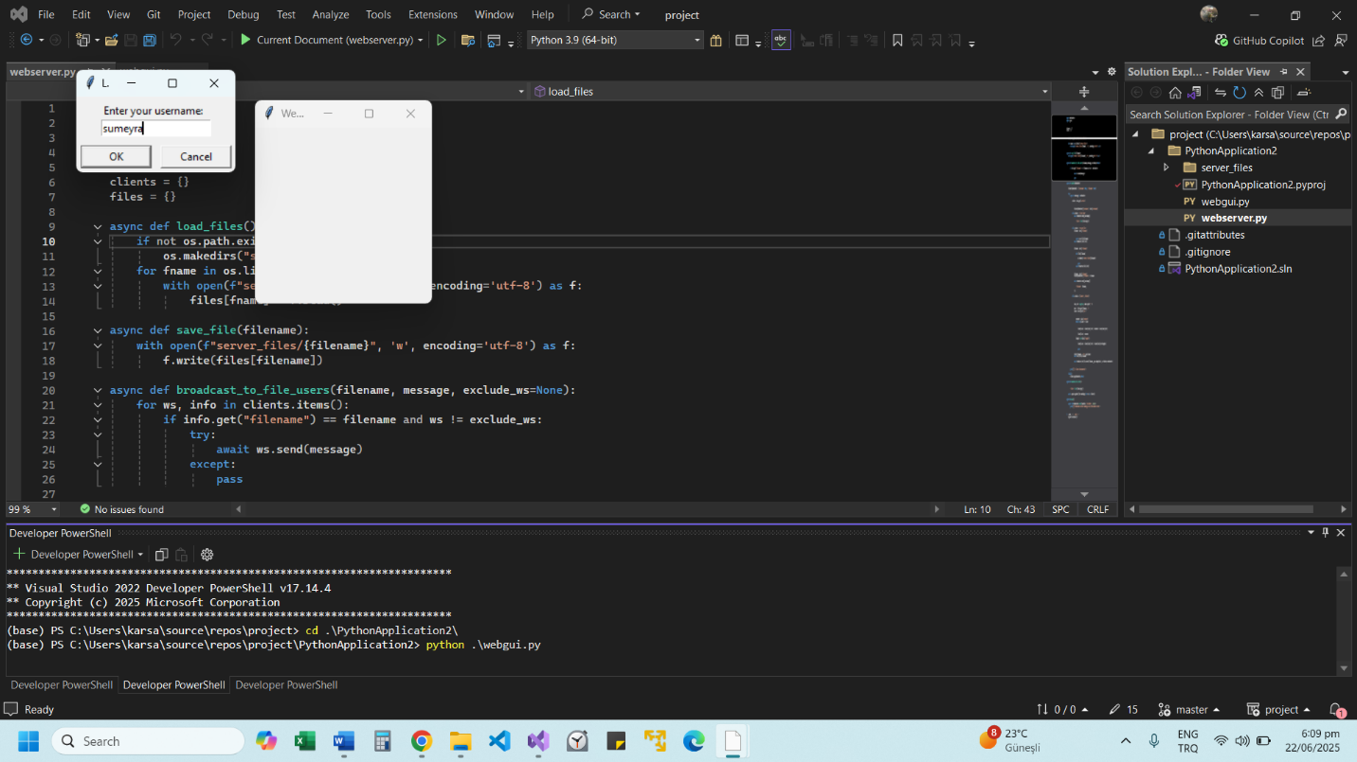

Enter the username and click on the arrow.

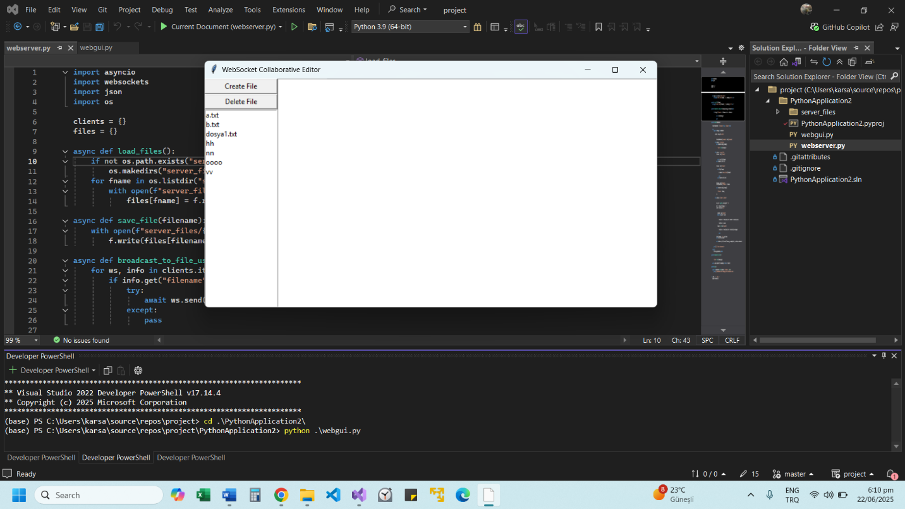

The text editor has been activated.

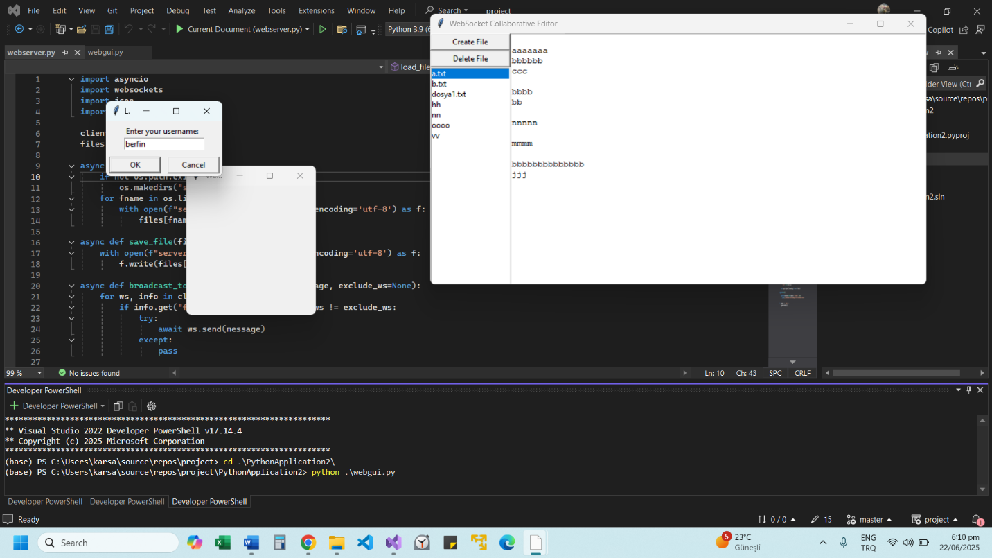

The environment is prepared for multiple users by running the client code again from another terminal.

Two users have the text editor opened at the same time. A.txt file content appears.

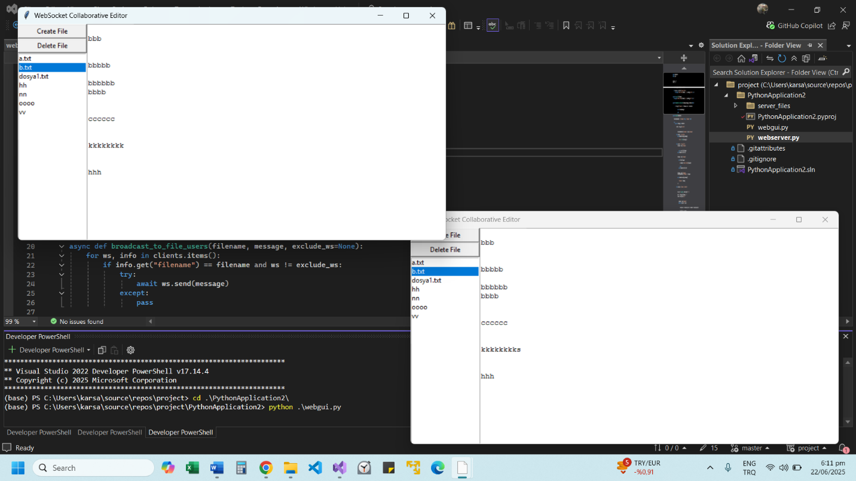

b.txt file content appears.

Vv file will be written and tested.

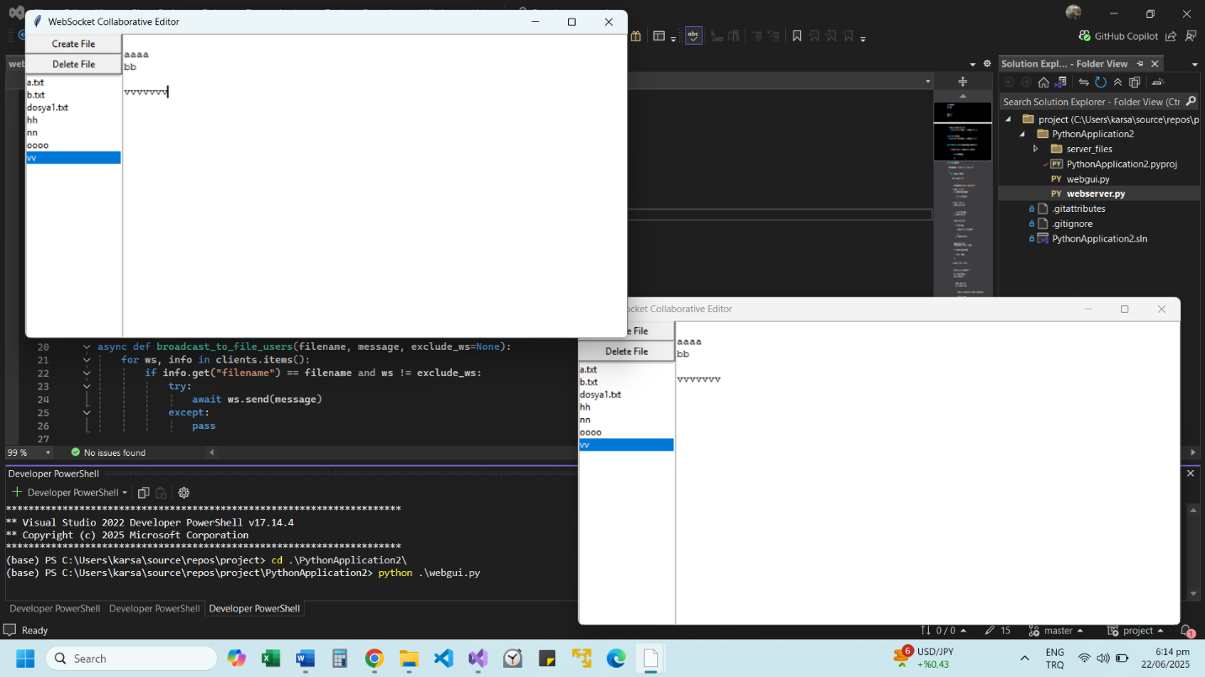

The letter v is written 7 times in the vv file. At the same time, the file content is updated instantly in the other user's interface.

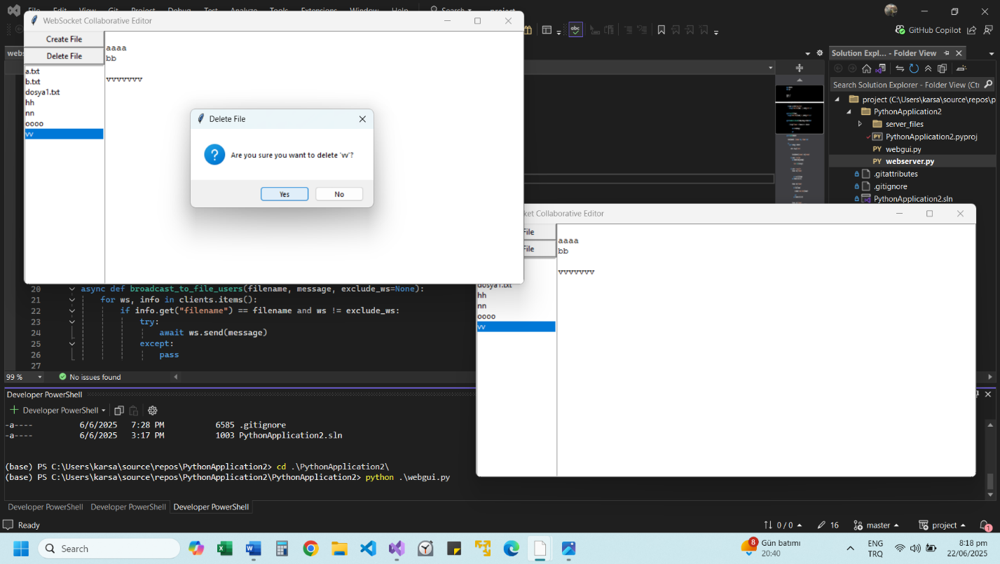

To delete the vv file, click the delete file button.

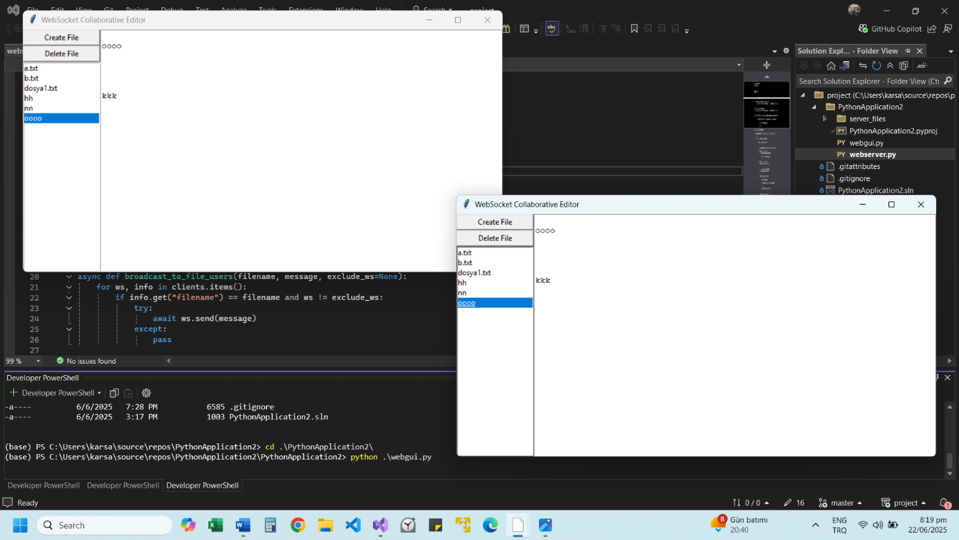

In the screenshot, it is seen that the file was deleted by the other user by deleting the vv file.

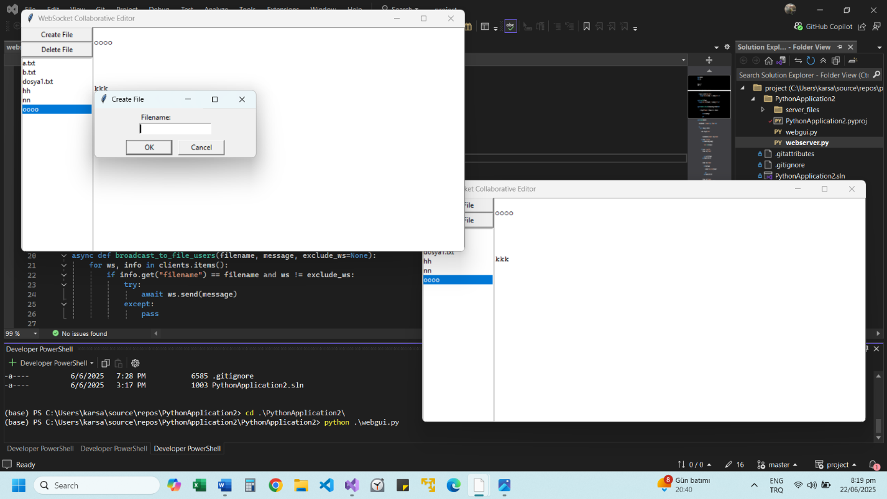

A new file can be created by clicking the Create file button.

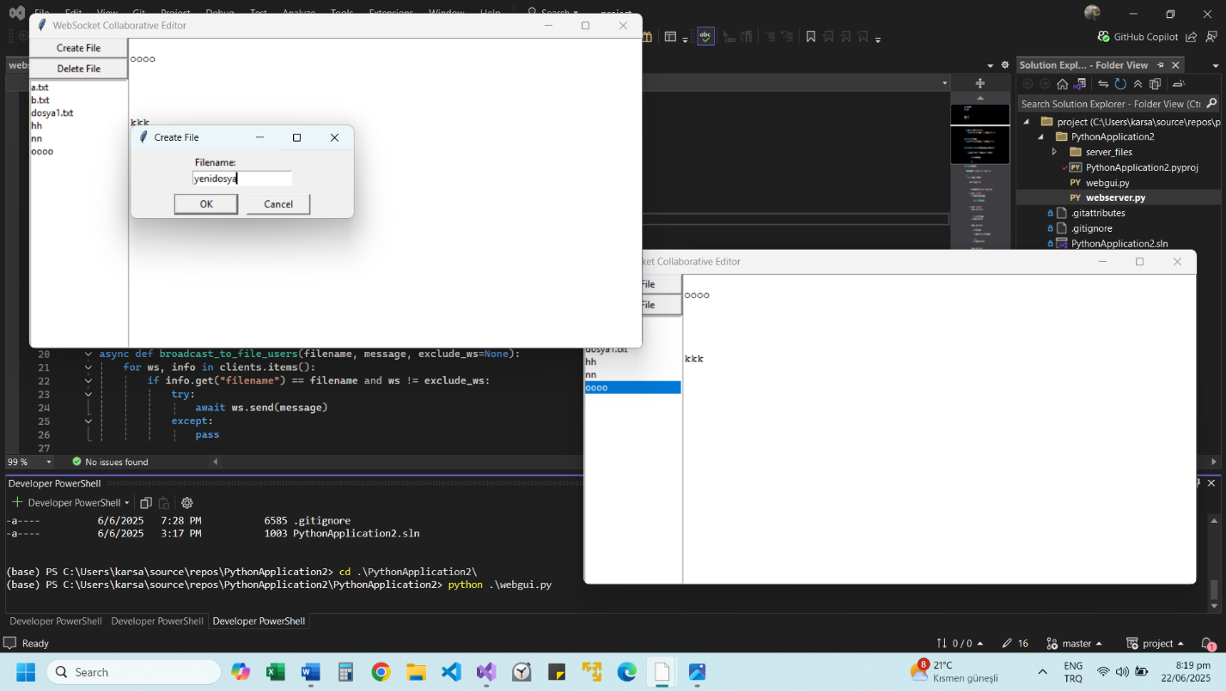

It has been named Yenifile.

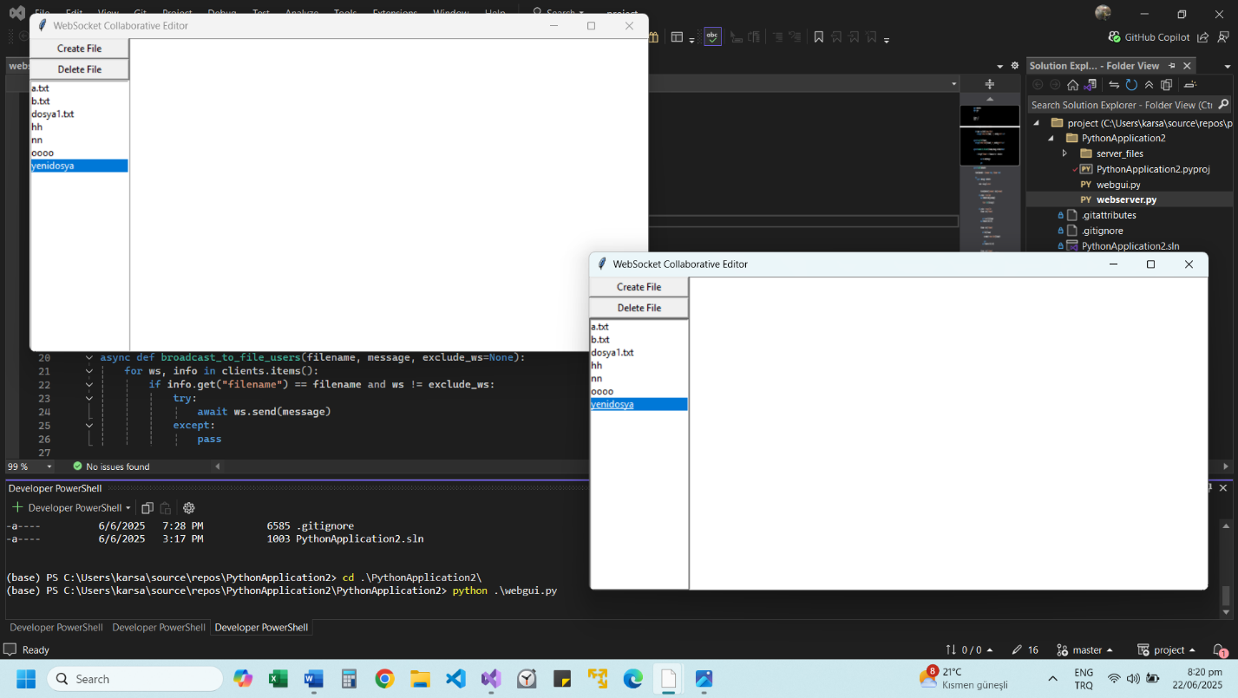

It can be seen in the screenshot that the file was created.

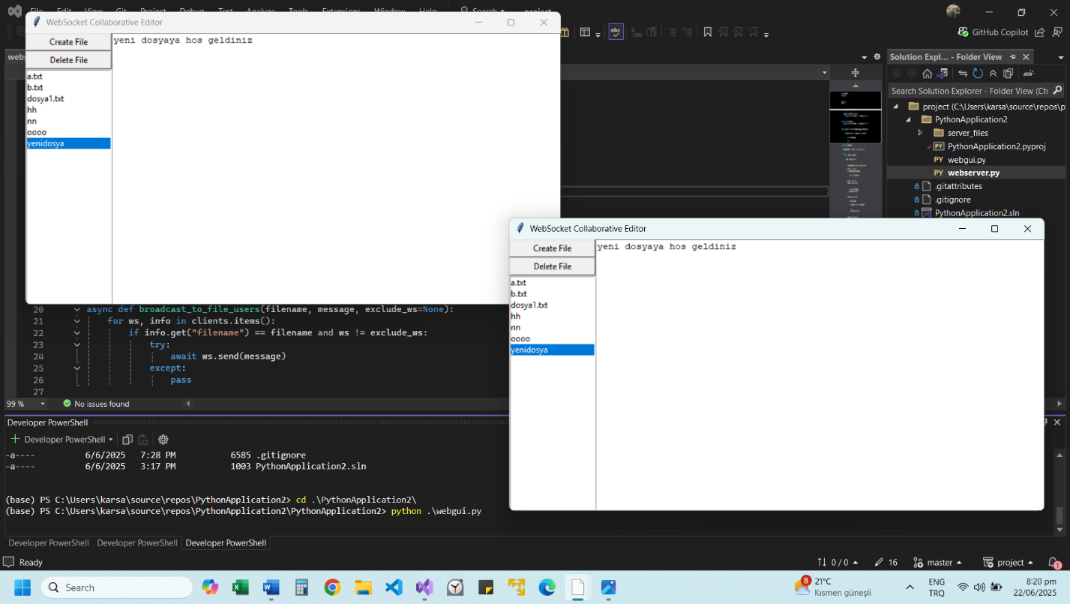

A text has been written in the new file content and it appears instantly in the other file.

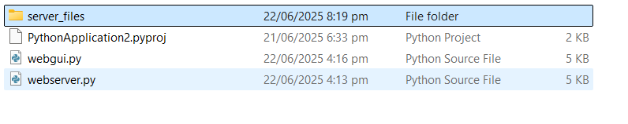

Files are saved in the server_files folder, as seen below.

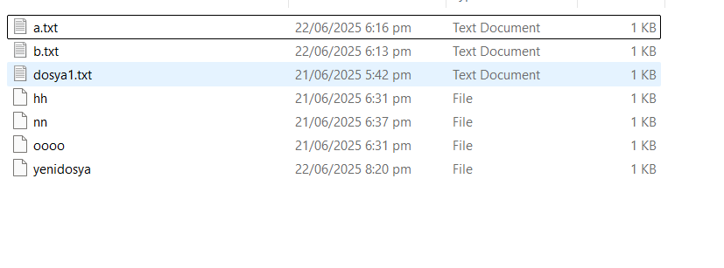

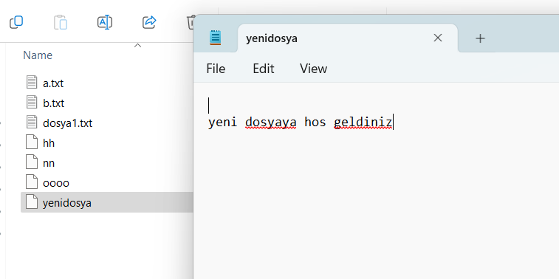

When the content of the new file is examined from the files, the article we wrote was saved.